Muscle Contraction

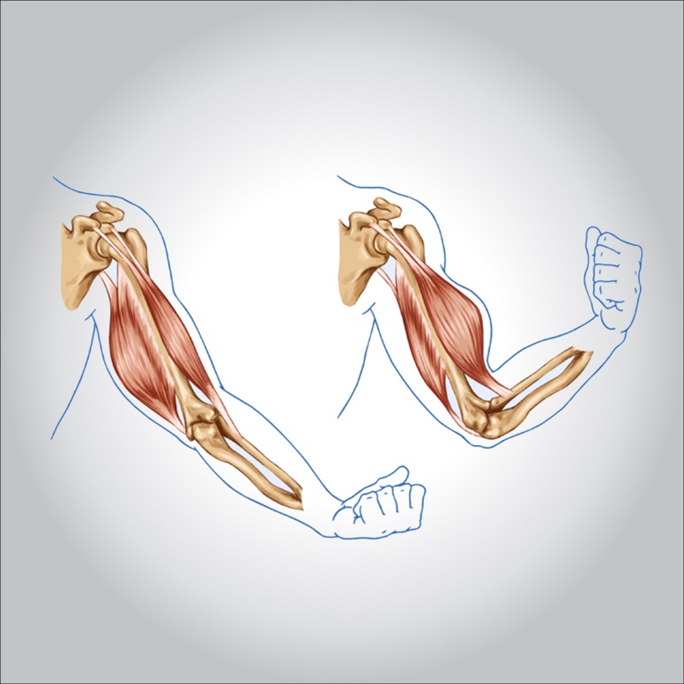

**It is the occurrence of muscle spasms without prior warning in a muscle or group of muscles so that the player cannot get rid of this severe painful contraction on his own and this spasm may continue for several seconds or a few minutes, and the most vulnerable muscles to this injury are (calf muscle Posterior and anterior thigh)**

**Symptoms of muscle contraction:**

* **involuntary contractions painful muscles, often in the leg**
* **A sense of extreme pain in the place of the contracting muscle and perhaps the entire limb**
* **Not being able to move the affected muscle or the affected muscle around it**
* **When examining the convulsive muscle, we find it stiff, the player cannot bear the fingers touching her due to the extreme sensitivity**

**Treatment:**

* **Make sure the muscle gets relaxed and the tension is removed. Surface wipes can be used using some warm paints.**
* **Pain relievers gradually**
* **Not to try to use rapid deep or violent massage movements during injury**
* **Make hot compresses for the affected area**
* **Apply the air cups system to the area of muscle contraction**